J277 Computer science mock exam revision Paper 1

Table of Contents
Character Sets 2
Binary 3
File Sizes 4
Binary Shifts 5
Central Processing Unit (CPU) 5
Storage 7
Legislation 8
Networks 9
Software Licenses 11
The Cloud 12
Images and Sound 12
Compression 14
Virtual Memory 15

Character Sets
Character sets are all the different characters that a computer can represent. The two common character sets are:
- ASCII or Extended ASCII
- Unicode

An ASCII character set can represent 256 characters. Each character is made up of 8 bits.
Q: If a text file has 1000 characters, how much is the estimated file size in Kilobytes:
Hint:
1 character = 8 bits

ASCII Table:
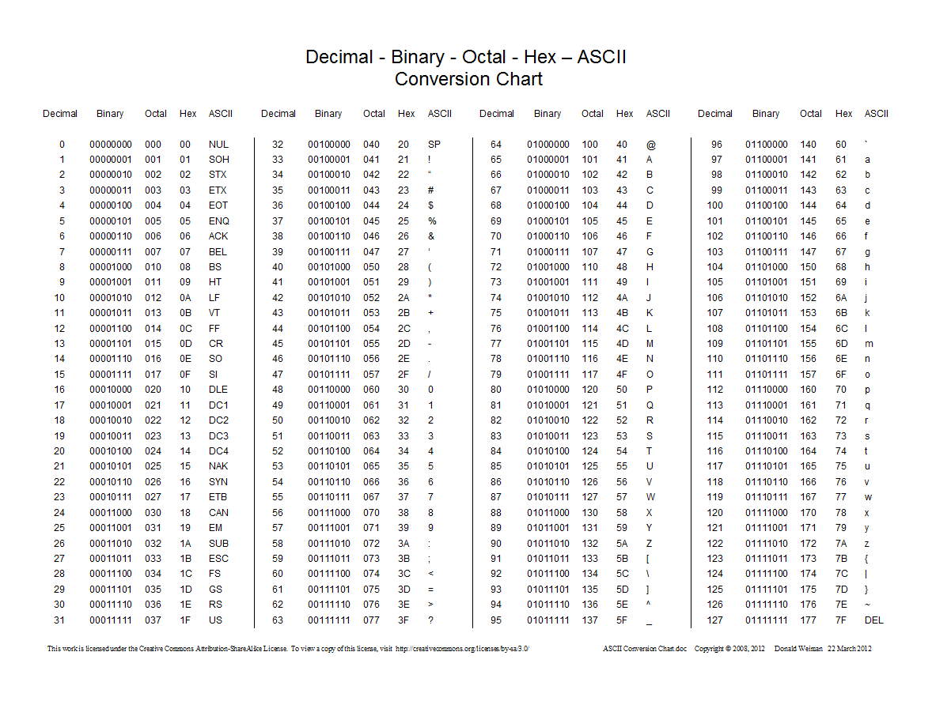

Q: What is the ASCII character K in 8-bit binary?

Q: What is the ASCII character L in hexadecimal?

Binary
Converting the following denary numbers into binary, and then convert them into hexadecimal.
- 23
Binary: | Hexadecimal:

- 49
Binary: | Hexadecimal:

- 123
Binary: | Hexadecimal:

- 90
Binary: | Hexadecimal:

- 128
Binary: | Hexadecimal:

- 54
Binary: | Hexadecimal:

- 12
Binary: | Hexadecimal:

File Sizes
Q: Put the file sizes in order from smallest to largest:
smallest largest

KB TB MB Byte Bit Nibble PT

Q: Calculate how many 3KB documents could be stored in a 10 GB hard drive.

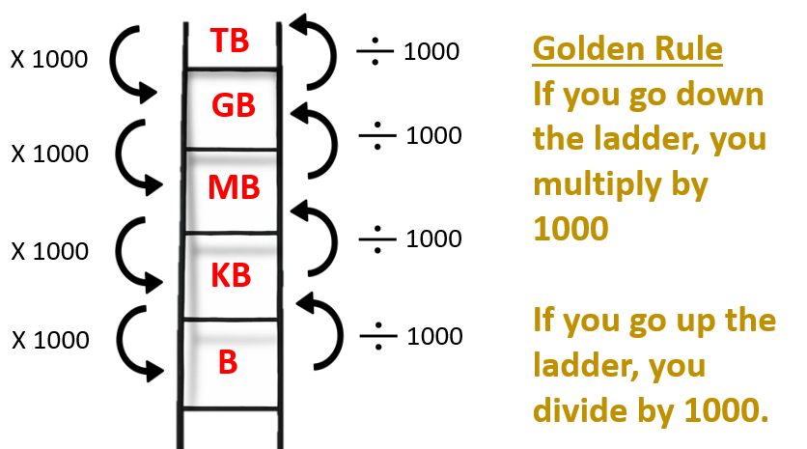

Binary Shifts
A left binary shift multiples a number and a right shift will divide a number.

Q: Carry out binary shifts on the following:

- Left shift by 1 place: 00110000

- Left shift by 2 places: 11110000

- Right shift by 1 place: 01011111

- Right shift by 3 places: 11110101

Central Processing Unit (CPU)
The CPU carries out the fetch, decode, execute cycle to process instructions.
It is made up of:
- Registers
- Control Unit
- Arithmetic Logic Unit

Registers are small amounts of memory in the CPU and the CPU has four.
Q: State the role of each register:
Program Counter

Memory Address Register

Memory Data Register

Accumulator

The performance of the CPU can be affected by its clock speed, number of cores and cache size.
Q: How does clock speed affect the performance of the CPU?

Storage
- Why does a computer need secondary storage?

- Why does a computer need primary storage?

There are three types of secondary storage devices:
- Magnetic
- Solid State
- Optical
Q: Explain two advantages of using each storage device.
Type | Advantages
Magnetic

Solid State

Optical

Legislation
There are four types of legislation involving computers:
- The Copyright Designs and Patents Act
- Data Protection Act
- Computer Misuse Act
Q: Explain, using one sentence, what each law outlines.
DPA

CMA

CDPA

Networks
Q: Name two features of a Wide Area Network.
Q: Name two features of a Local Area Network.

Networks can be connected using wired and wireless methods, there are different standards for each method.
Q: Tick which method each standard is.
 | Wired | Wireless
Wi-Fi
Ethernet
Bluetooth

Q: A house has computers in each room and a central router. Every room allows both Ethernet and WiFi connections to the router.
The following table has descriptions of Ethernet and WiFi.
Tick one box in each row to identify if the description is more appropriate for Ethernet or WiFi.

 | Description | Ethernet | Wifi
 | A wired connection
 | More likely to be affected by interference
 | Data can be transmitted at a faster speed
 | Wireless transmission
 | Shorter transmission range before data is lost

Network hardware is the physical parts that you need to set up a network.
Q: Name three roles/features of a router.
Q: Name three roles/features of a switch.

Q: Network performance can be affected by many factors. Fill in the table with either the definition or the factor.
Factor that affects network performance | Description
 | The physical media used to connect computers in a network together. For example, a fibre optic cable which has high speeds.
Network Topology
Number of users
 | The measure of how much data the network can transmit at a given time. The higher this is, the better the performance of the network.
Latency
Q: Name three protocols that are used to send emails:

Q: Which protocol is used to load web pages securely?

Networks can be set up using two models, client-server and peer-to-peer.
Q: Define the following words:
Client
Server

Software Licenses
There are two types of software licenses, which outline what you can and cannot do with software.
Q: Tick either open source or proprietary for each feature in the table.
Feature | Open Source | Proprietary
Free to use
Paid for
Created by professional companies
Created by the community
Source code shared
Source code is not shared

The Cloud
Cloud Computing is storing data and files on the internet, rather than on your own computer network.
Q: Explain three advantages of using Cloud Computing.

Q: Explain three disadvantages of using Cloud Computing.

Images and Sound
Q: Describe the following words in relation to the way sound is represented on a computer system:
- Sample Rate

- Bit Depth

Q: Explain how sampling is used to convert a voice recording into a digital form.

Q: What affect does increasing colour depth have on the:
- Quality of the image

- File size

To calculate colour depth you work out 2 to the power of n where n is the number of bits used per pixel.
For example, to work out the colour depth of a picture which uses 3 bits per pixel:
2 to the power of 3 = 8 colours

Q: What is the colour depth of an image that uses 4 bits per pixel? Show your working.
Q: What is metadata? Explain and give one example.

Compression

Compression is used to reduce the file size of an image.

Q: Describe the features of:
- Lossy compression

- Lossless Compression

Q: Which compression method would you use to compress a word document? Why?

Virtual Memory

Virtual memory is needed when the computer runs out of RAM.
Q: Describe the steps that the computer takes when moving data to and from RAM/virtual memory.

