Cambridge National Level 1/2

Child Development

Unit R018 – HEALTH AND WELL-BEING FOR CHILD DEVELOPMENT

L5: Know about child safety
Assessment Criteria:
  - – How to create a safe, child friendly environment.
  - – Safety Labeling.
  - – To be aware of the most common childhood accidents.
  - - Social Safety.


Pages:
45 - 55
Name: _________________________________________

Bedroom Hazards
Living Room Hazards
Bathroom Hazards
Kitchen Hazards
For each of the rooms identify the possible risks.

Date: ___________________
Assessment Criteria:
1.1– How to create a safe, child friendly environment.

Describe what parents can do to ensure that their house is safe for a child.

Add other peoples to your mind maps as we go through the class.
Safety Equipment Hazards
Road Safety Hazards
Garden Hazards
Stairs Hazards
Plenary - Identify three ways a early years setting can be made safe for children.

1 - _________________________________________________________

2 - _________________________________________________________

3 - _________________________________________________________

Safety Equipment

- Harness and reins
- Safety glasses
- _______________ for cupboards and window
- Safety_______________
- Socket covers
- Play _________________
- ______________ alarms
- Cooker guards
- Firefighting equipment
_________________ Hazards – objects that can be tripped over.

_________________ Hazards – insecure windows.

________________ Hazards – heaters and electrical appliances.

______________________________ Hazards – unsafe produce.

_______________________________ Hazards – Stranger danger.
What is the difference between a Hazard and a Risk?

With your row create a poster about how to make each room safe. At the end of the lesson ensure that you have a poster about each room.

Use pages 62 – 65 to ensure that you have each point within your poster.

Make it colourful and ensure that

Why is it important that there are safety labels on products designed for children?

Date: ___________________
Assessment Criteria: 1.2 – Safety labeling.





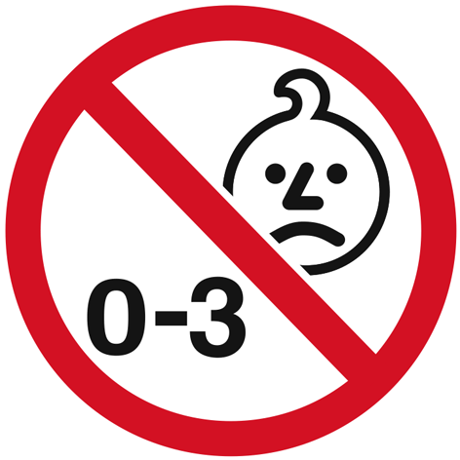



Suggest 5 ways that early years settings can make sure that the toys they give children are safe and age appropriate.

1 - __________________________________________________________________________________________________________________

2 - __________________________________________________________________________________________________________________

3 - __________________________________________________________________________________________________________________

4 - __________________________________________________________________________________________________________________

5 - __________________________________________________________________________________________________________________

What accidents do you think are common for children?

Date: ___________________
Assessment Criteria:
1.3 – To be aware of the most common childhood accidents.
- what should early years settings do if a child has had a head injury?

- Why is first aid training important in early years settings?

What is CPR?

1 - _______________________________________________________________________________________________________________

2 - __________________________________________________________________________________________________________________

3- _______________________________________________________________________________________________________________

4 - _________________________________________________________________________________________________________________

5 -___________________________________________________________________________________________________________________

6 - __________________________________________________________________________________________________________________

7 - __________________________________________________________________________________________________________________

8 - __________________________________________________________________________________________________________________

9 - __________________________________________________________________________________________________________________

10 -_________________________________________________________________________________________________________________

Date: ___________________
POP QUIZ
Name: ______________________________
Why is it important that a child knows about personal safety?

Why is stranger danger important?

How can parents keep their children safe on the Internet?

Assessment Criteria: 1.4 – Social safety.

Date: ___________________

Who are safe people that children can talk to about any of these problems?

Why is it important that a child knows about internet safety?

What can Early Years setting do to promote personal safety?

Playgroup worker Sara works with Shelly and Carly, whose parents are friends – the girls sometimes visit each other’s houses. Sara has noticed that when Carly’s mum arrives to collect Carly, Shelly often thinks she is going home with her. But Carly’s mum is not authorised to collect Shelly. Sara mentions to Shelly that is could be a good idea to talk to Shelly about who she is allowed to leave with.

Shelly’s mum ask Sara why she should talk to her daughter about this? What reason should Sara give?

Why do parents have to inform the Early Years Setting about who is allowed to collect the child from the setting?

What is Child grooming? ________________________________________________________________________________

What is cyber bulling? ___________________________________________________________________________________

How can early years settings help teach a child stranger danger?

How can early years setting monitor a child's use of computers and internet?

Extra Notes/ Revision:

