Cambridge National Level 1/2

Child Development

Unit R018 – HEALTH AND WELL-BEING FOR CHILD DEVELOPMENT

LO1: Understand reproduction and the roles and responsibilities of parenthood.

Assessment Criteria:
1.1 – Wide range of factors affecting decision to have children.
1.2 – Pre-conception Health
1.3 – Roles and responsibilities of parenthood.
1.4 – Recognise and evaluate methods of contraception, their efficiency and reliability.
1.5 – Structure and function of the male and female reproductive system.

Why is this an important factor in deciding to have a child?

Relationship between

_______________

Factors that affect the decision to have children

Starter: complete the brainstorm.
Assessment Criteria:
1.1 – Wide range of factors affecting decision to have children.
Date: _________________

Why is this an important factor in deciding to have a child?

Why is this an important factor in deciding to have a child?

Age

Pressure
Why is this an important factor in deciding to have a child?

Genetic counselling for genetic _______________
Why is this an important factor in deciding to have a child?

Complete the table with advantages and disadvantages of being an older or younger parent.

Younger parents Advantages and disadvantages. | Older parents advantages and disadvantages

To Be healthy I need to…..

Date: _________________
Assessment Criteria: 1.2 – Pre-conception Health

Research the areas of health we have discussed as being important.

Why are they important?
Describe what needs to be done for a person to have good health in this area.

AREA TWO __________________________________

AREA ONE __________________________________

AREA FOUR __________________________________

AREA THREE __________________________________
Plenary Answers

AREA FIVE __________________________________

COLD HOT

1

2

3

4
Questions

1 – What is one primary need?

2 – What is one secondary need?

3 – Why do parents need to show a child love?

4 – give one way you can socialise a child.
Describe why it is important that children’s primary needs are met?

Date: _________________
Assessment Criteria: 1.3 – Roles and responsibilities of parenthood.

Describe why it is important that children’s secondary needs are met?

How can you improve a child’s social interaction as a nursery worker?

Describe how an adult can be a good role model to a child.

Why is sleep important?

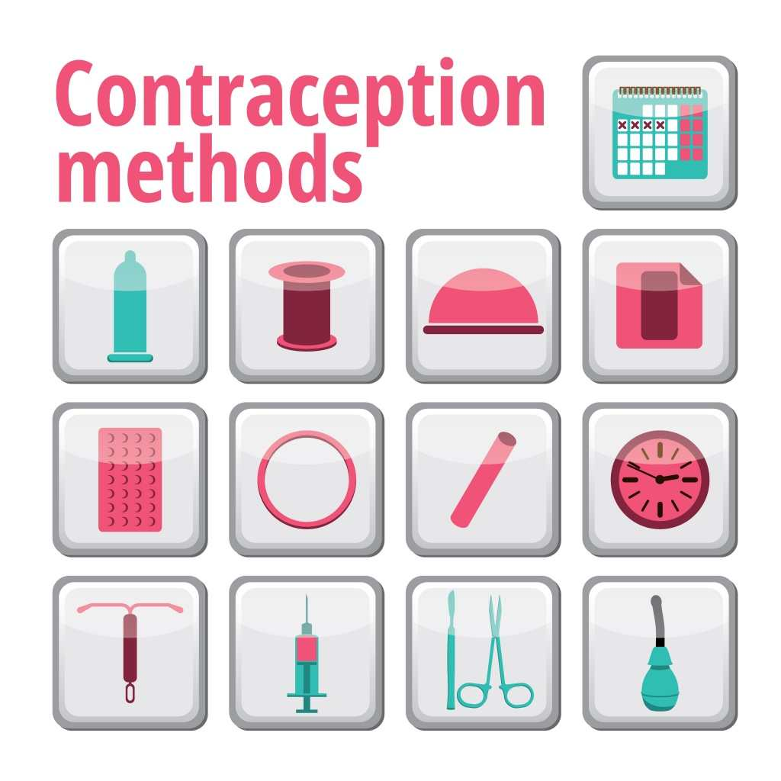
Types of contraception?
Date: _________________
Assessment Criteria:
1.4 – Recognise and evaluate methods of contraception, their efficiency and reliability.

How many types can you name?
Complete the types of contraception we are looking at:

  - ___________ and female _______________
  - _______________________ or cap
  - ___________________________________________
  - intrauterine ____________________________
  - Contraceptive __________________________
  - Contraceptive __________________________
  - _________________________________ implant
  - Natural _________________________________
  - Emergency ________________________ pill

Take a picture of your game, to be printed out.

Who’s game did you like best?

Who’s game was most effective?
Why?
Date: _________________
Assessment Criteria:
1.5 – Structure and function of the male and female reproductive system.

Question | Cold Answer | Hot Answer
1 – what is a sperm cell?
2- where are egg cells produced in the woman?
3 – what happens first impregnation or fertilisation?
4 – do women have a vas deferens?

Print out a labelled copy of the male and female reproductive system, and a picture to show the development of a foetus.

What parts make up the male reproductive system?
What parts make up the female reproductive system?
Reproduction:

What is ovulation? _______________________________________________________________________________

Describe what happens at fertilisation.

What are the differences between identical twins and non-identical twins?

What happens during implantation?

Signs and symptoms of pregnancy:

Unscramble the anagram and then match the description.
Breasts may feel similar to before a period and feel tender. Nipples become darker.
SESDIM EDPORI

Increased feeling of tiredness due to hormonal changes. Emotions can be more irregular.
LTOS FO UERNI

Missing a period is often the first sign or a very late period. Most reliable if the woman has a regular period cycle.
STSIERNED

Needing to go to the toilet more, and sometimes constipation.
TBSRAE CSHEAGN

Feeling sick or being sick, often called ‘morning sickness’, but can occur at any time of the day.
ANAESUN
Complete the table below.
Female reproductive system |  | Male reproductive system
Part | Function | Part | Function
Ovaries |  | Testes
Fallopian tube |  | Sperm duct/epididymis
Uterus / lining of uterus |  | Urethra
Cervix |  | Penis
Vagina |  | Vas deferens
Menstrual cycle

______/ 5
1 – Daniel and Maxine have been trying for a baby. State 5 signs and symptoms of pregnancy that Maxine may notice should she conceive.

_______/ 3
______/ 5
2- As they prepare for their new baby Daniel and Maxine are considering the roles and responsibilities of parenthood. State five primary care needs that they will need to meet.

3- State how reproduction takes place.

